Xoxoday’s products empower organizations with enhanced employee experience through rewards & recognition, incentive & out-of-the box loyalty programs. Products provide the organization’s leaders with necessary actionable insights and all key HR metrics delivered in real time, while seamlessly integrating to HCM (human capital management) solutions like SAP SuccessFactors, and other systems.

Xoxoday is the #1 Software to make "Rewards and Incentives" look simple. 1000's of businesses of all sizes, from start-ups to large enterprises, use Xoxoday’s technology & APIs to calculate incentives, send rewards, manage commissions & disburse payouts online. Xoxoday's product suite integrates with daily-use Apps helps businesses to digitize rewards and incentives in under 60 minutes.

Mission: Xoxoday's mission is to digitize incentives for 100,000 businesses across the globe by 2025. Because incentives can't run on spreadsheets for long!

Frogo: Frogo is a marketplace of activities, experiences, interesting professionals and things to do. Discover & Book amazing Experiences, Activities, meet interesting professionals and Things to do in city or destinations.

Giftxoxo: Giftxoxo is a marketplace for gifting unique experiences and gift vouchers. Gift Memories, not Things with Giftxoxo.com

Xoxoday: Xoxoday provides SaaS platform for Digital Rewards, Recognition, Benefits & Engagement. HR Leaders, Sales Leaders and Marketers use it to get better ROI for spends in the Human Capital & Marketing program.

-Plum (Rewards catalog & API)

Xoxoday‘s Plum will help you simplify your digital rewards and recognition program across your employees, channels or consumers, thus helping create better employee experiences for a better customer experience.

Xoxoday Plum is a digital rewards platform that also offers a global catalogue of 20,000+ options with 5,000+ experiences, 2000+ gift cards and 12,000+ perks. The platform offers a rich and varied catalogue to users, with categories such as wellness, personal finance, e-learning, e-gift cards, experiences, privileges, philanthropy, rentals, perks, offers, and subscriptions.

-----An employee benefits and rewards management solution

-Empuls (Employee engagement & rewards)

Helps solve business critical challenges related to reducing employee turnover, attrition, improving employee productivity and increasing employee happiness.

------An employee engagement solution with features as workplace communications, employee feedback & survey, recognition, perks management, etc

-Compass (sales commision & incentives)

Xoxoday’s Compass, will help to increase revenue, reduce your operational challenges to execute an engaging incentive program, thus building high performance culture, improving channel visibility. This in turn helps improve sales and channel NPS.

-----A gamification-based employee motivation solution with features as analytics & insights, goals & performance management, etc

1. I love the WHY behind the product.
2. It is a B2B but the end customers are all the employees that work for Xoxo’s client organizations.
3. The name Xoxo has a very homely, family & love vibe to it- meaning the companies should treat their employees as their family, which is achieved by the Xoxoday product??
4. Organisations get to define what user behaviour they want to reinforce and set up custom triggers to run reward programmes.
5. Most organisations today already use a technology platform or solution to streamline their business operations like HR, finance, sales, marketing, support or other functions. **The Xoxoday Plum platform has been designed in such a way that it can be integrated with these software or solutions to further drive business efficiency. “This eliminates the larger challenge of disconnected and siloed data when organisations begin using an increasing number of tools and technologies,**” says Manoj Agarwal, Co-founder at Xoxoday.
6. With its plug-and-play model, an organisation can go live with Xoxoday Plum in under 60 minutes, a process which can otherwise take up to two or three months.
7. They are ranked #9 amongst the top 50 fastest growing tech-companies by Deloitte in 2018.
8. Xoxoday had ranked #20 in the Deloitte fastest growing technology companies in 2020.
9. Xoxoday, a SaaS commerce company, crossed **Rs 100 crore turnover ($13.4M)** for the financial year 2018-19.
10. Xoxoday has **242 employees**. They have 32 sales reps that carry a quota. They have an engineering team of 57 and a marketing team of 12.

There are 3 products that they offer. The Xoxoday for Employees product enables HRs and CXOs to improve employee happiness and engagement. The Xoxoday for Channel product helps channel managers create an engaged distributor and retail partner network. Xoxoday for Rewards product offers an API driven digital rewards platform to simplify rewards, recognition and incentive programs with a global catalogue of 5000+ experiences, 1000+ gift cards and 10,000+ perks.

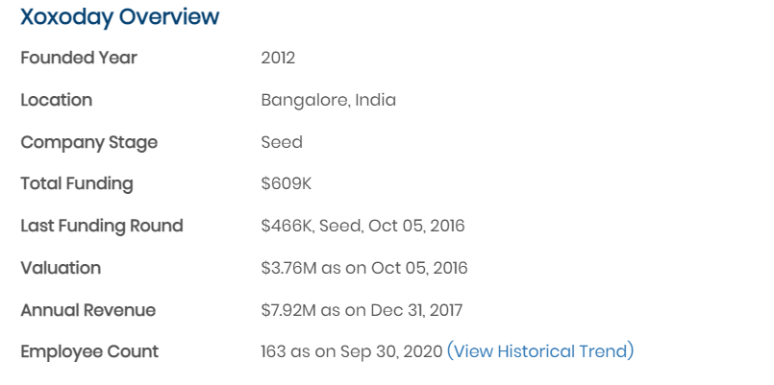

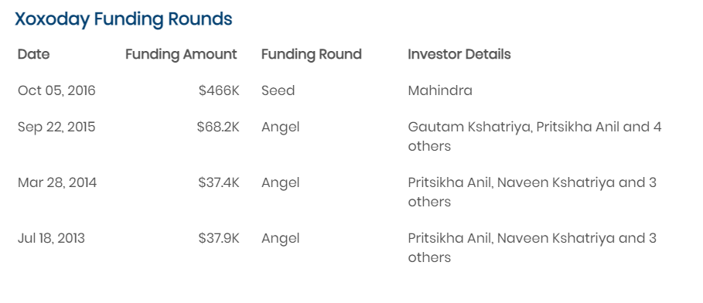

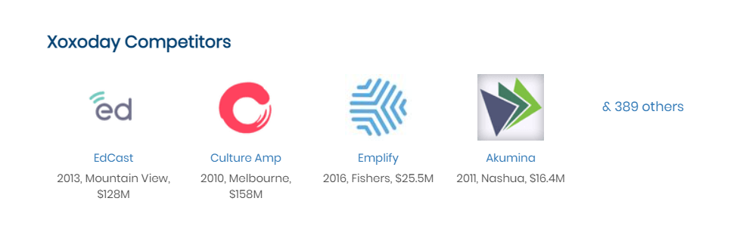

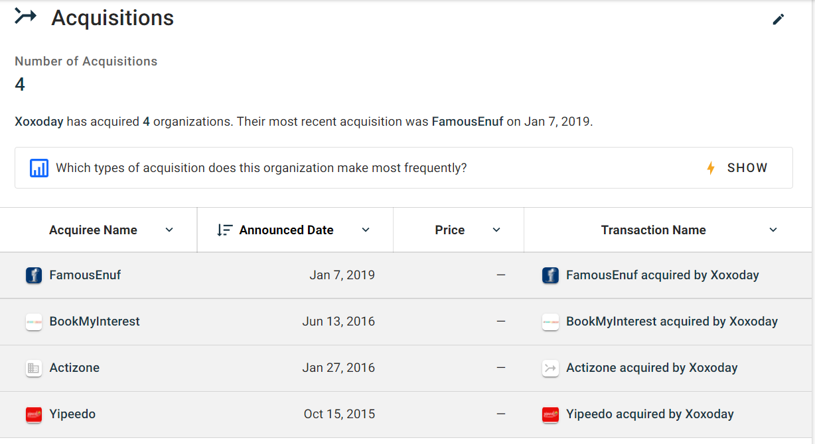

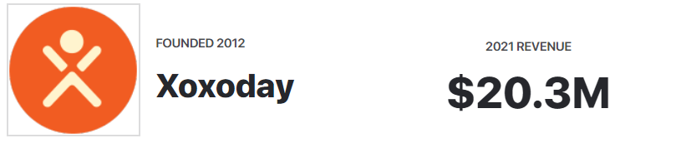

* The **impact has been manifold** for organisations leveraging Xoxoday Plum. While for some, it has eliminated the manual intervention which are time-, cost- and manpower-intensive, for others it has eliminated the ambiguity around effectiveness of a rewards programme.
* Improves company’s brand image & employment brand